16SW180
 |  | Department of Software Engineering
 | Mehran University of Engineering and Technology, Jamshoro
 | Course: SWE324 - Data Warehousing and Data Mining
Instructor | Rabeea Jaffari | Practical/Lab No. | 11
Date | 15-08- 2018 | CLOs
Signature |  | Assessment Score | 1 Marks

Topic | Data mining technique: association rule analysis
Objectives | - | To learn and implement various classification machine learning
 |  | algorithms with Azure
 | - | To evaluate the results of classification algorithm

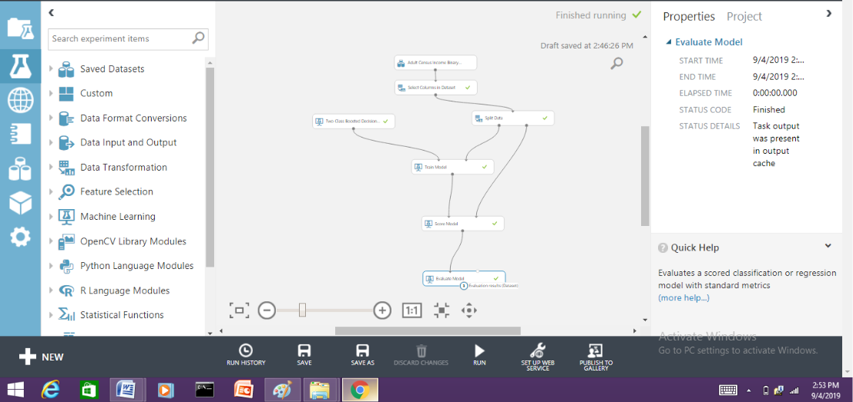
TASK 1
Lab Discussion: Theoretical concepts 